
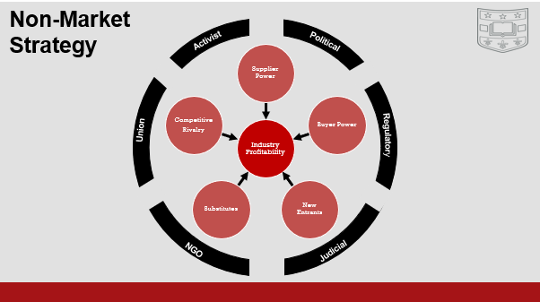
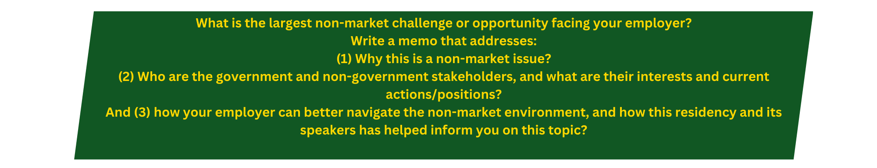
The Boeing Company manages its operations as several business units: Boeing Commercial Airlines (BCA), Boeing Defense and Space (BDS), Boeing Global Services (BGS) and AvionX which operates as an internal supplier of electronic devices for use in any of the three larger umbrellas. I work within AvionX where we pride ourselves on our ability to operate as a small team within the large Boeing umbrella and to interface at the intersection of public goods and commercial products by selling our designs to BDS and BCA. Boeing meets non-market challenges every day and AvionX must be cognizant of all of them since we operate as part of both the commercial, and defense branches. Some non-market challenges we face include, 1) a destabilized global community and wars in two continents. 2) An information war going on via the internet between the US, China, and other countries that targets Boeing and others. 3) A trend towards distrust of institutions and a political climate that attempts to benefit from that distrust. 4) Union labor contracts which are revisited every several years and intertwine dangerously with some of the other issues listed above. Each of these issues is on its own interesting and important but given Boeing’s financial year the most prominent issue is what our CEO calls a crisis of trust between our customers and the Boeing Company.
The Crisis of trust stems from primarily two events in recent history: the crash of Alaska Airlines Flight 261 and the door plug blowout from Alask Airlines Flight 1282 on the Boeing 737 MAX9 airplane. These are at their core product quality failures. For another company a failure of this kind would be a market issue and for Boeing it is too, but the non-market issues that follow are far more troubling for our company. The non-market issues that come from Boeing’s quality failures hit the company from many of the directions reflected in the chart above. After Boeing’s quality failures the FAA has increased its oversite of all business activities which increases time and costs to all designs. The FAA also controls the number of planes the company can sell by month which reduces income. In the political space Boeing has been brought to testify to Congress more than once which resulted in the removal of the CEO and a great deal of damage to the Brand. On the Judicial side Boeing has been hit with some large fines which are currently on hold as the case against the company is prosecuted. The pressure brought from each of these factors caused a great deal of financial damage to the company at the same time as the Seattle Union contract expired which gave great leverage to the union over the company and played a part in the recent strikes on the west coast where 737’s are manufactured.
Today, some of these factors have hit a temporary resolution. Congressional hearings and Judicial prosecution are ongoing for the Boeing Company as the judge presiding the case has recently rejected Boeing’s guilty plea in pursuit of a higher degree of punishment. The union contract has been settled but did result in the furloughing and layoffs of thousands of Boeing Employees as well as a reduction in R&D project funding to generate future income. The hit to brand image has faded some or become memory holed (judging by the number of Boeing headlines I see) but the FAA’s restrictions and oversight will remain until Boeing can prove compliance to policies many competitors can self-govern.
The question of how Boeing can better manage its non-market issues is a challenging one but the solution is often painted broadly by our leadership. Boeing needs to change its culture and is making steps to achieve that goal. By removing Dave Calhoun and replacing him with Kelly Ortberg as CEO the company is signaling a pivot away from financial engineering towards a more reliability minded leader with a Defense background. To me this shows the recognition that Airplanes are more alike to a public good even in the private sector than they are alike to a commercial product. The processes of financial engineering and lean enterprise that lead to a lower cost product do not often translate to a better one.
Boeing will need to do a better job in its engineering management of procedures to re-estimate the cost of failures and weigh the cost of each of these non-market factors accurately in discussions around product and program cost. I liken this kind of a cost model conversation to a conversation I had with Amy Nelson during the round tables at Brookings. She spoke about the risk modeling that goes into nuclear disarmament. Using complex probability and best guess information from experts her team helps to analyze decision making and negotiations about arms policy in hopes of achieving disarmament and greater world stability. In a similar way, the Boeing business makes thousands of decisions each day and no one of these individually leads to a catastrophic failure like the ones mentioned above. Within those decisions, there must be nearly zero tolerance for a failure of the model (or a failure of quality) that leads to catastrophe. Even small cost cutting measures must be viewed in the light of a larger model that keeps our customers safe. By changing discussions about cost to overemphasize the cost of quality, Boeing can better protect its customers and derisk negative influences from non-market factors.



